Use this same template every day, for every task, throughout all 6 phases. Fill in every field before submitting.
1 | 📋 Intern & Task Details

Intern Name | Mohamed Imthiyas A
Phase / Day | Phase 5/ Day 46
Date | 17/08/2026
Task / Topic Title | Plugging in the ML Model – Flask ML Prediction API
Time Spent (hrs) | 1

2 | 📝 Summary of Work Done
2–4 sentences: what did you build or learn today?
Today, I integrated the existing Phase 2 Machine Learning model into the Flask backend of the Student Management project. I separated the ML prediction logic from the Flask routes, loaded the model when the application starts, and created a /api/predict endpoint to receive input and return predictions as JSON. I also tested valid and invalid requests using Postman and verified that the existing Student Management APIs continued to work correctly.

3 | 👣 Steps Followed
List the key steps you completed, in order.
- Verified the existing Phase 2 ML model independently by loading the model and testing it with sample input to confirm that predictions were generated successfully.
- Created a separate ML prediction module to handle model loading, input preparation, inference, and prediction output.
- Integrated the ML module with the existing Flask application so that the model is loaded once when the application starts instead of being loaded for every request.
- Created and tested the POST /api/predict endpoint, including input validation, prediction generation, JSON response handling, and invalid-input error handling using Postman.

4 | 🧩 Challenges Faced & How You Solved Them

The main challenge was integrating the ML prediction logic without mixing it directly into the Flask route code. This was solved by separating the model-related operations into a dedicated ML module and calling the prediction function from the API endpoint. I also handled invalid, missing, and empty request data through input validation so that incorrect requests return meaningful JSON error responses instead of causing the Flask server to crash.

5 | 💡 Key Learnings
What’s the one thing you understand better now than this morning?
I learned how to integrate a trained Machine Learning model into an existing Flask REST API and expose its predictions through an HTTP endpoint. I also understood the importance of loading the model once during application startup, validating API input before sending it to the model, and returning predictions in a consistent JSON format that can be consumed by a frontend application.

6 | 🔗 Proof of Work

File(s) / Folder Name | App,py  postman/Student_Management_API.postman_collection.json  model.pkl
GitHub Repo Link | GitHub
Screenshot Attached? | Yes
Live/Deployed Link (Later Phase)

Screenshots:

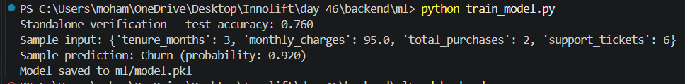
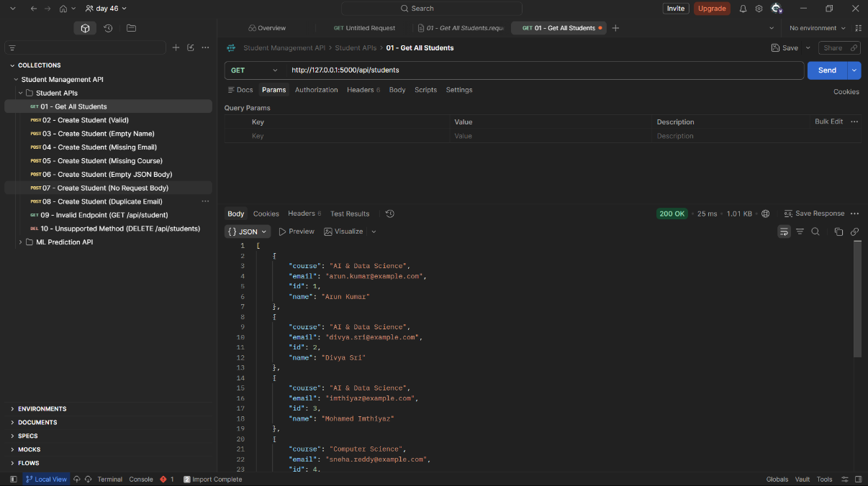
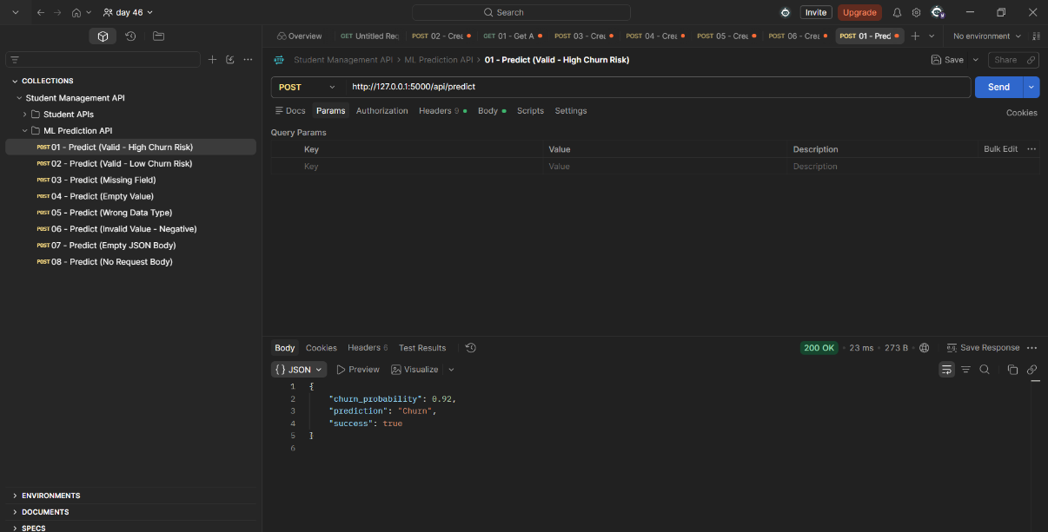

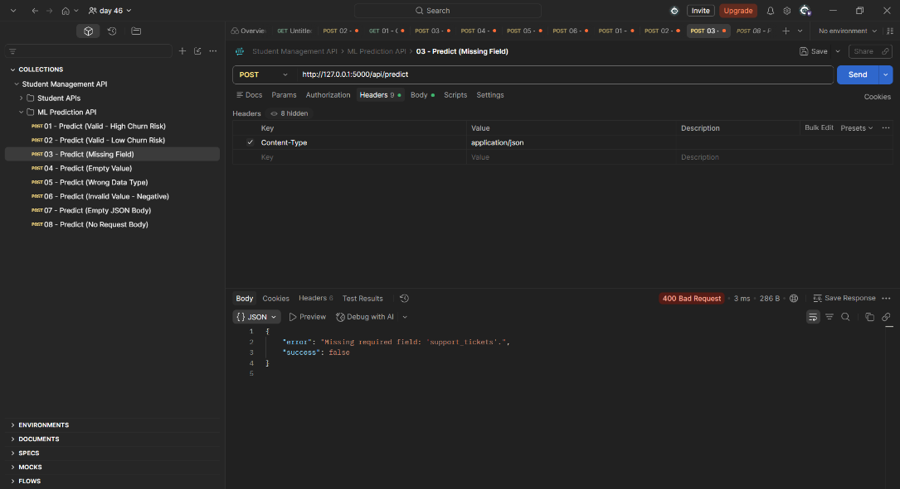
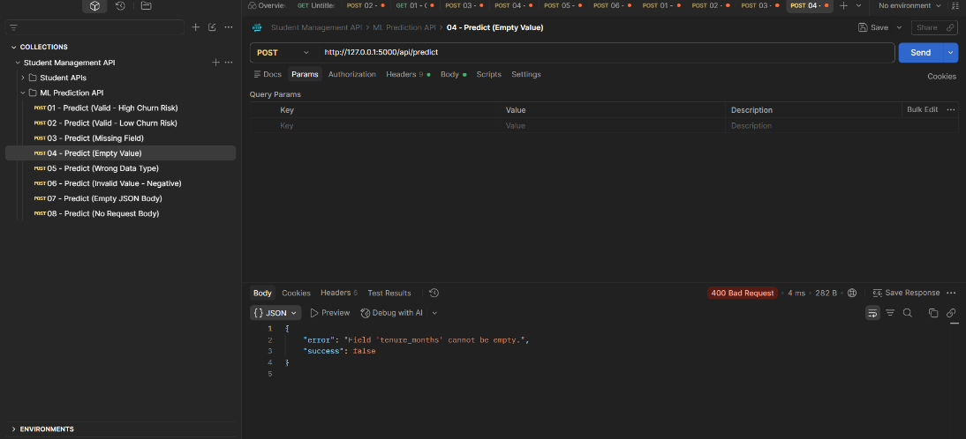

7 | ⭐ Self-Assessment

Star Rating | ⭐ ⭐ ⭐ ⭐ ⭐  (circle or fill in stars — 1 = needs help, 5 = fully confident)
Comments | I am confident with the basic integration of a Machine Learning model into a Flask backend. I successfully connected the model to an API endpoint, implemented input validation, tested the endpoint with Postman, and verified that the existing backend functionality was not affected.

8 | 🎯 Mentor Feedback (left blank by intern)

Status
Comments

